

*Organisation: Solar Boat Sealander*

*Client: Mr. R. Eijlers*

*Tutor: Mr. W. Haak*

*Date: 24-10-2020*

System test plan

Propulsion system simulation

Fangzhou chen Jiacong li Marco Hoogesteger Martijn Crombeen

2020

Table of content

1. Aim & Hypothesis 2

1.1. Aim 2

1.2. Hypothesis 2

2. Variables 2

2.1. Inputs 2

2.2. Outputs 2

3. Tools 3

4. Method 3

4.1. Steps 3

5. Expected results 4

6. Conclusion 4

# Aim & Hypothesis

## Aim

The aim of this test is to verify the simulation of the propulsion system of the Solar boat.

## Hypothesis

The simulation will be verified according to the performed tests.

# Variables

These are the constants and variables that will be used during the test.

|  |  |
| --- | --- |
| Constants simulation | Keep constant at... |
| Ambient temperature | Standard indoor temperature with lower and upper limits (20 ℃ ± 5℃). |
| Battery level computer | Constant power source. |
| Software Excel | Newest version. |
| All input variables | Real positive numbers & ISO-notation. |

|  |  |
| --- | --- |
| Constants physical measurements | Keep constant at… |
| Water wave frequency | *Waves in harbor, will not be taken into*  *consideration.* |
| Water flow velocity |
| Water wave amplitude |
| Motor power source | Boat battery pack. |
| Test setup thrust | Nihil movements, setup is fixed to make measurements as precise as possible. |
| Test setup boat velocity | Sensor attached to boat at fixed position. |

## Inputs

The limits stated are the limits of the real world. If values out of this range are entered, the outputs will be unreliable.

|  |  |
| --- | --- |
| Inputs | Value |
| Motor input voltage [V] | Change value between 0 & 48 in equal steps |

## Outputs

These are the outputs that will be monitored and will be used to see variations or changes in the system.

|  |  |
| --- | --- |
| Outputs | Value |
| Thrust [N] | Indicator between 0 & 500 |
| Boat velocity [m/s] | Indicator between 0 & 10 |
| Prompts or warnings for successful or failed simulation | Simulate successfully / unsuccessfully |

# Tools

We divide the tools into two types. The first one is “testing tools” which are the tools requires to perform the test. The second one is “measuring tools”, which are the tools required to measure the given limits and properties.

|  |  |
| --- | --- |
| Testing tools | Demand |
| Computer | Windows 10 compatible |
| Excel | Newest version |
| Keyboard | No limit |
| Mouse | No limit |
| Calculator | Basic calculator |
| Pen & Paper | Basic pen & paper |

|  |  |  |
| --- | --- | --- |
| Prototype Measuring tools | Demand | |
| DC Voltage meter | Min. Range from 0 to 100 V | |
| Current meter | Min. Range from 0 to 200 A | |
| Hanging scale | Min. Range from 0 to 50 kg | Waterproof |
| Boat velocity meter (GPS) | Min. Range from 0 to 10 m/s |

|  |  |
| --- | --- |
| Environment Measuring tools | Demand |
| Wind speed + direction sensor | Set constant at 1 in simulation. |
| Humidity sensor |
| Temperature sensor (motor temp.) |
| Temperature sensor (ambient temp.) |

# Method

This section consists of actions that need to be performed during the test to conclude a result. The conditions of the constants stated in chapter “2. Variables” have to be met before executing the simulation. To execute the simulation, follow the steps stated in “4.1. Steps”.

To validate our design, we simulate the current propulsion system and measure the real values of the prototyping setup. We then compare the measured values to the simulation outputs and improve the simulation so that the calculated values are within an error margin of the measured values. When this is the case for all the measurements, we can state that the calculation chain is validated.

In case the boat is not available for testing, we will perform the same steps and calculations, only the simulation will not be validated yet.

## Steps

**Measuring thrust**

1. Put the boat in the water and attach the hanging scale to a fixed point on the end of the hull and the dock.
2. Attach the multi-meter to the battery.
3. Setup all the environmental sensors.
4. Set the gas pedal to ascending positions from 0 to max. in quarter steps (0, 0.25, 0.5, 0.75, 1).
5. For each position, read the motor input voltage and current, the value on the hanging scale, and the data from the environmental sensors.
6. Notate values in a table.

**Measuring boat velocity**

1. Put the boat in the water and attach the velocity meter to a fixed position in the boat.
2. Attach the multi-meter to the battery.
3. Set the gas pedal to ascending positions from 0 to max. in quarter steps (0, 0.25, 0.5, 0.75, 1).
4. For each position, read the motor input voltage and current, the value on the velocity meter, and the data from the environmental sensors.
5. Notate values in a table.

**Measuring simulation data**

1. Set up computer and load in simulation.
2. Insert measured motor input voltages and currents.
3. Run the simulation for each measurement.
4. Compare results with measured thrust and velocity values.

# Expected results

The expected results of the outputs are as followed.

When the boat sails at full speed (20 km/h or 5,55 m/s), 2500 [W] of physical power is delivered.

$F_{fullspeed}=\frac{P}{v}=\frac{2500}{5,55}=450 [N]$.

$$F_{speed0.75}=450*0,75=337,5 \left[N\right] for v_{0.75}=5,55*0,75=4,16 [\frac{m}{s}]$$

$$F_{speed0.50}=450*0,50= 225 \left[N\right] for v_{0.50}=5,55*0,50=2,78 [\frac{m}{s}]$$

$$F_{speed0.25}=450*0,25=112,5 \left[N\right] for v_{0.25}=5,55*0,25=1,39[\frac{m}{s}]$$

# Conclusion

When the outputs of the simulation do not deviate more than 30% of the measured values for thrust and velocity, we state that the simulation passes the test.

When the outputs of the simulation deviate more than this range, we state that the simulation failed the test.

Now that the electrical input power and mechanical output power is calculated/measured, the efficiency can also be shown.

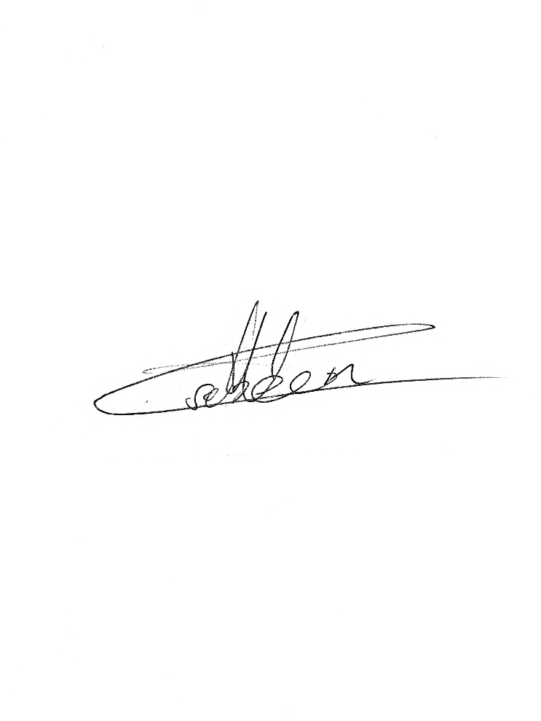

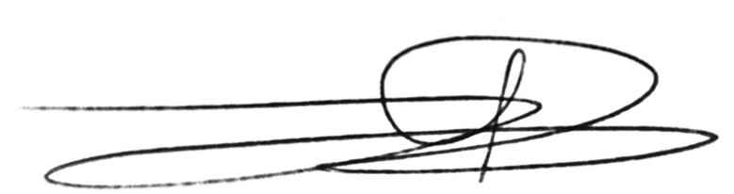Signed by group 1 Signed by Mr. Bardolf

Date: 16-10-2020 Date: 16-10-2020